

IM4717

Web Application Design

Design Project Report

|  |  |  |
| --- | --- | --- |
| **Name** | **Matric No** | **Group Number** |
| Jack Teo | U1820218F | F34-DG14 |
| Goh Jun Bin | U1822878D |

# 

## 

## Contents

Contents 2

Project Title 4

Project Summary 4

Application requirements and specifications 4

R1. Search for movies 4

R2. View movie descriptions 4

R3. View available movie timings 4

R4. View seat selections 4

R5. Ticket purchase transaction 5

R6. Marketing and promotions 5

Functional requirements and specifications 5

F1. Search for movies 5

F2. View movie details 5

F3. View available showtimes 6

F4. View seat selection 6

F5. Ticket purchase transaction 6

F6. Marketing and promotions 6

Sitemap 7

Storyboard 8

Header/ Navigation Bar Storyboarding (Coming Soon and Now Showing) 8

Header/ Navigation Bar Storyboarding (Promotions) 9

Search Bar Storyboarding (Part 1) 10

Search Bar Storyboarding (Part 2) 11

Ticket Purchase Storyboarding 12

Wireframe 13

Home page 13

Now Showing 14

Now Showing: By Genres (Via Search) 15

Coming Soon 16

Promotions 17

Promotions (View Modal) 18

Movie Details 19

Movie Showtime (Via search by movie and date) 19

Genre Showtime (Via search by genre and date) 21

Seat Selection 22

Transaction Page (Success) 22

Transaction Page (Fail) 24

Implementation details 25

CSS 25

Header and Footer 25

Promotion page - Modal 25

Search bar 25

Homepage - Carousel 25

Movie Gallery 25

Movie Details and Showtime 25

Seat Selection 25

Transaction Page 26

Testing of web applications 27

Test Case 27

## Project Title

Designing and building of a Cinema Web Portal.

## Project Summary

This is a web design and development project that aims to build a cinema web portal, for customers to view movie details, showtimes and book seats online. This report will walk through the decision-making processes behind the design principles. In the future, HTML, CSS and JavaScript programming languages will be utilized to build this project.

## Application requirements and specifications

### R1. Search for movies

There is a requirement for users to be able to quickly navigate to a movie of their choice through the use of a search function. They may wish to search by the movie title, date of screening, and even showtimes. This function should allow users to be instantly redirected to the relevant page.

Furthermore, an additional ‘movie genres’ search option can be added in hopes of allowing the users to better match their preferences.

### R2. View movie descriptions

Another requirement is for users to have the ability to find out more about the movie they might be interested in. Information such as movie title, genre, rating, duration and synopsis will be provided on the individual movie’s web page. Additionally, users may also quickly find out important information about these movies by simply hovering over each movie poster image. This will allow a way for users to have a quick idea on the movies that are currently airing, and act as a way to convince ticket purchases as a form of marketing.

### R3. View available movie timings

Users must be able to preview all the showtimes of a movie within the selected day. The page should also allow a good flow between different movie screening dates, so that users do not need to re-do the search process every time.

### R4. View seat selections

Users must be able to preview the available seats, so that they can select the seats they want to purchase a ticket for. Rather than tickets being assigned at an orderly fashion, or even random. Having a preview accommodates for the customer’s seating preferences, where movie-goers often sit together when multiple tickets are purchased, and also allow the user to decide whether the seating angle and distance is suitable for them.

Since this page directly leads to the payment function, it should show a preview of total cost, and also information such as the movie title, date, time and screening theatre. This would enable the user to be confident enough to proceed with the purchase, knowing what he is paying for, and how much.

### R5. Ticket purchase transaction

While the payment is handled by a third party, a confirmation page displaying the transaction details would still be necessary to inform the users of a successful or unsuccessful transaction. It should also show ticket collection details and a summary of the purchase, with details such as the total cost, price and transaction ID.

### R6. Marketing and promotions

The ‘Now Showing’ and ‘Coming Soon’ pages should be available as part of marketing and promotion. Users will be able to view the attractive movie posters and possibly discover more movies to their liking (similar to the Genre Search function).

An additional separate page for exclusive Promotions offered by the cinema, such as movie snacks discount deals would be good marketing utilities.

## Functional requirements and specifications

### F1. Search for movies

The search bar will be positioned at the header of every webpage. Since it is used through multiple pages, the layout and alignment should be exactly the same. The search bar will consist of 3 main dropdown lists which are movies, date and time respectively. As mentioned previously, it will also feature a fourth search option, for genres, in hopes of letting users discover more movies. Users will need to select either a movie or movie genre before they can execute the search function.

When the genre option is selected, the user will only be able to select a date as the time dropdown selection will be disabled. Depending on their choices, it will redirect the users to different webpages:

1. If they select a specific movie only, they will be redirected to the movie details webpage.
2. If they select a genre only, they will be redirected to the Now Showing page containing movies for the selected genre.
3. If the user selects a genre or movie, combined together with a date, they will be redirected to the showtime page for their selection.
4. If they select a movie, date and time, they will be redirected to the seat selection page.

The time dropdown option is therefore optional and users should only select a time if they are ready to buy tickets.

### F2. View movie details

We will offer 2 ways for users to approach the details of the movies. Firstly, by hovering over the movie’s poster that is displayed on our homepage it will display brief details of the movie. If they are interested and want to find out more, they can then click on the movie poster, which will redirect them to the movie’s individual web page containing detailed descriptions of the movie. Below the description, there will be a section with a table containing the showtimes of the movie. Each row will display the showtimes of each day (ranging to about 3 days). Users will be able to click on any of the showtime to proceed to the seat selection page of that specific screening.

### F3. View available showtimes

With a movie and showtime selected in the search bar, this page will be displayed, previewing the movie showtimes of the selected period. Just like within each movie’s individual web page, the showtimes will be displayed within a table element, with each link clickable to redirect them to the seats selection page.

### F4. View seat selection

In the seat selection page, it will display the theatre model showing the seats availability, screen positioning and the entrance/ exits. With this visual diagram, users may easily interact by clicking and selecting desired seats. Seat availability will be distinguished by colour coded to indicate seats that are taken, available or seats that the user has currently selected for purchase.

It is important for seat availability to be real-time and accurate to the booking database, and not allow for incidents such as duplicate or overlapping bookings.

### F5. Ticket purchase transaction

There will be a confirmation page to notify users of the validity of their ticket purchase transaction. In the case of a ticket purchase error (e.g. someone has already bought the ticket), the user will be directed to a failed version of the Transaction Page and prompted to try again. Otherwise, the page will reflect the successful purchase details as per the updated database.

### F6. Marketing and promotions

For both marketing (now showing and coming soon) and promotions, there will be posters or images for users to hover/click to find out more. For Marketing, users could find out more information about the movies. In the coming soon web page users could also find out when the movie will be airing. While for promotions, they will be able to find out of the different promotions that are being offered. The posters or images will be displayed in rows of 3.

## Sitemap

## 

## Storyboard

### Header/ Navigation Bar Storyboarding (Coming Soon and Now Showing)

### Header/ Navigation Bar Storyboarding (Promotions)

### 

### Search Bar Storyboarding (Part 1)

### Search Bar Storyboarding (Part 2)

## 

### Ticket Purchase Storyboarding

## 

## Wireframe

### Home page

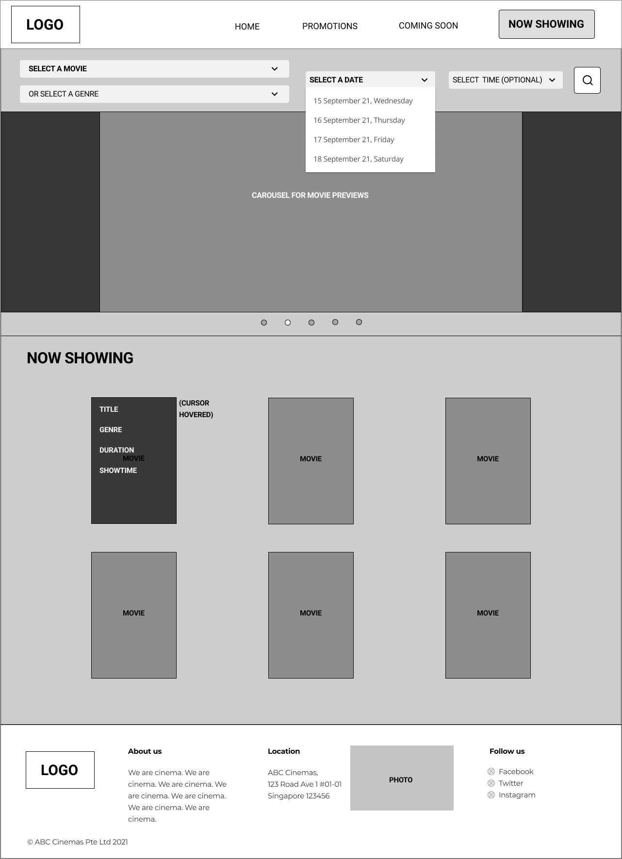

### Now Showing

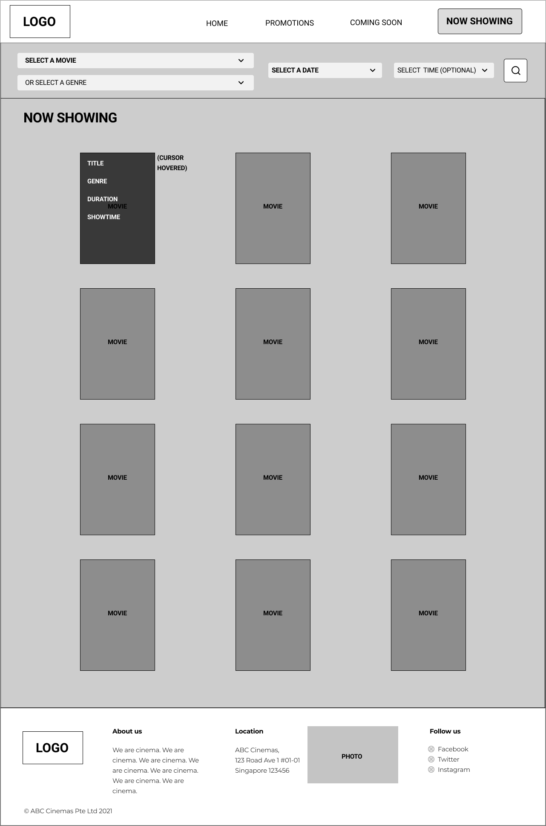

### Now Showing: By Genres (Via Search)

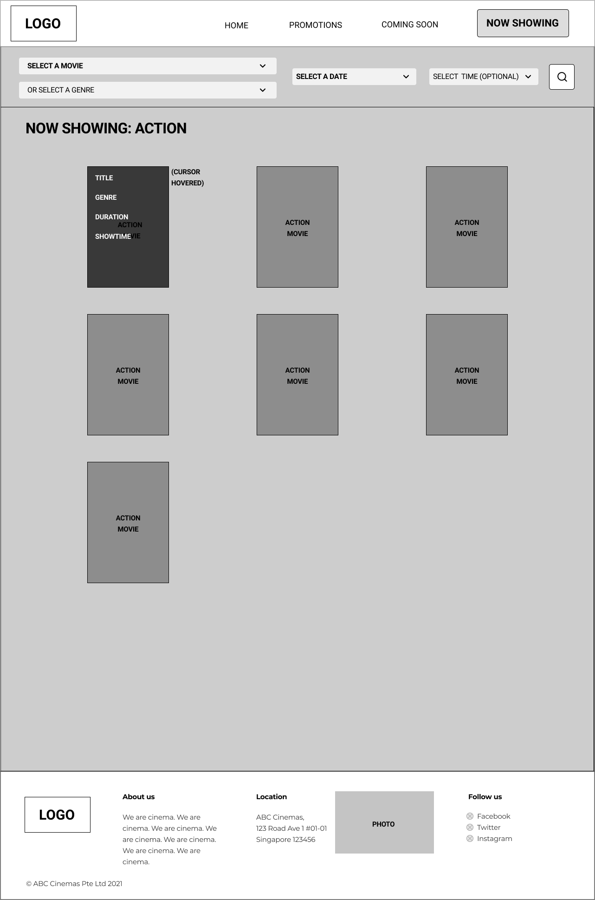

### Coming Soon

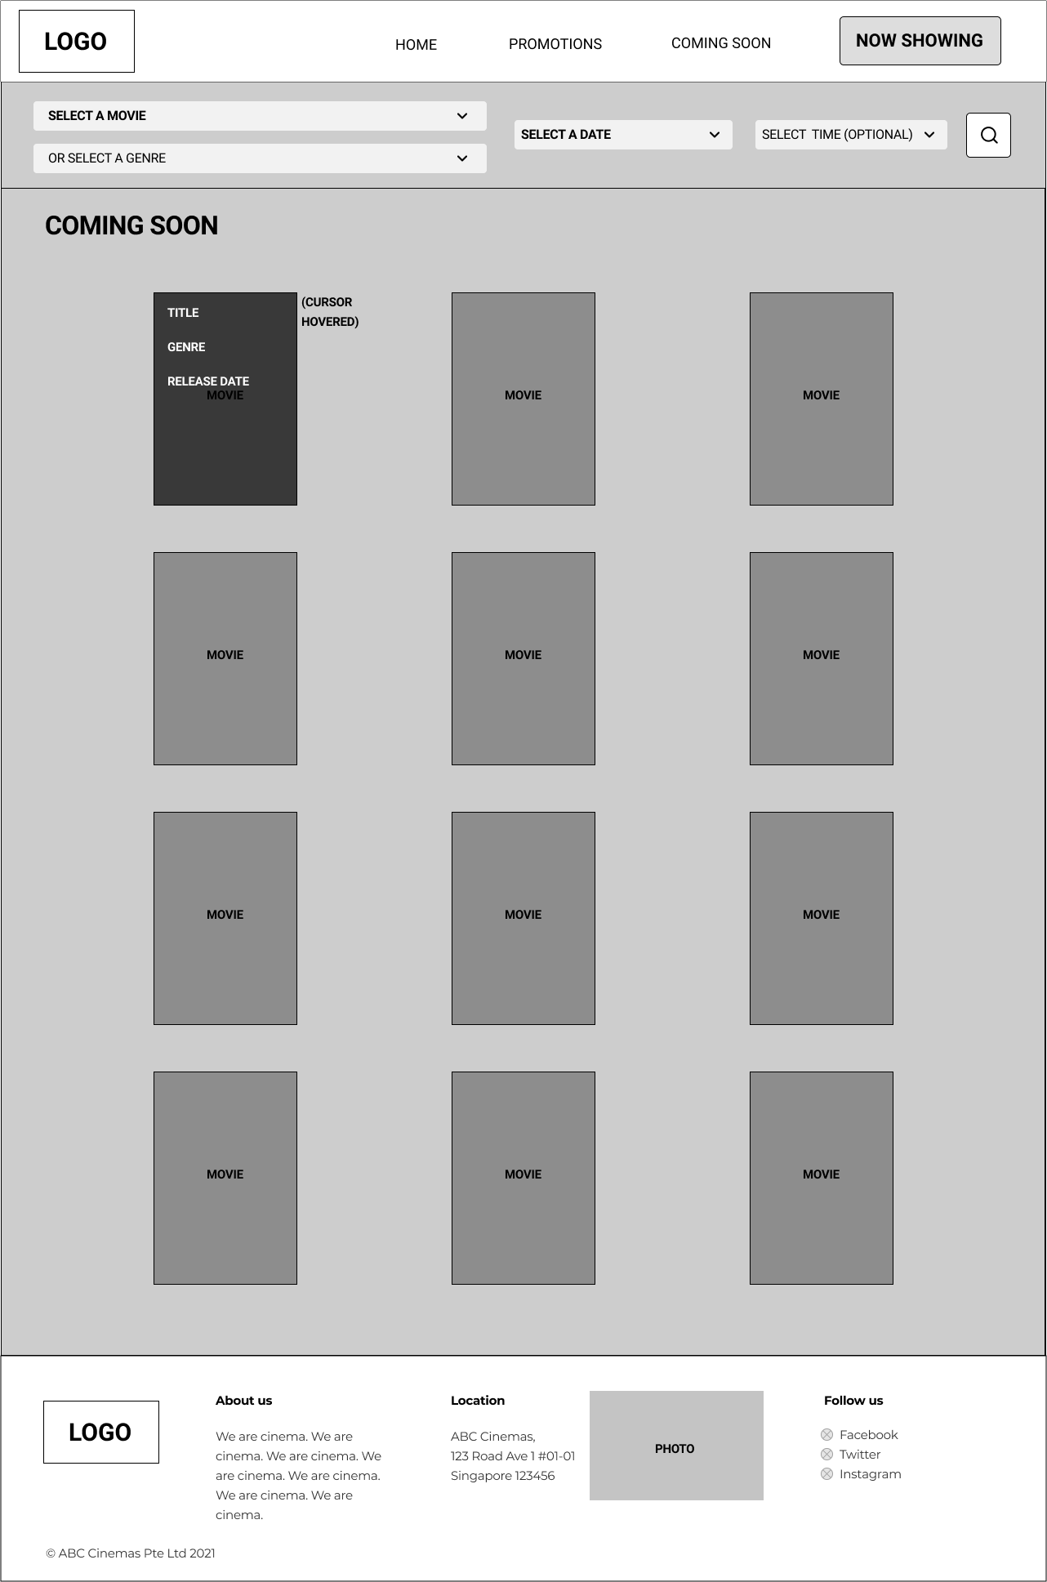

### Promotions

### 

### Promotions (View Modal)

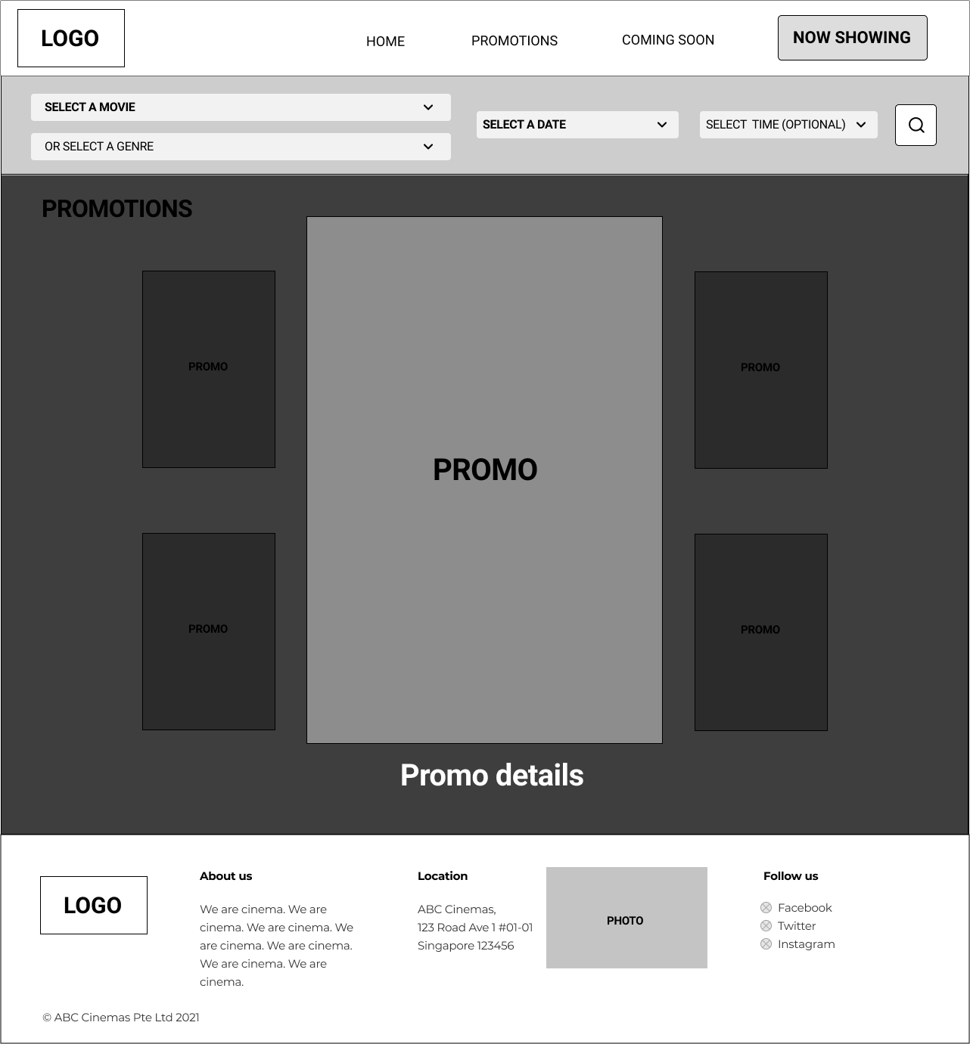

### 

### Movie Details

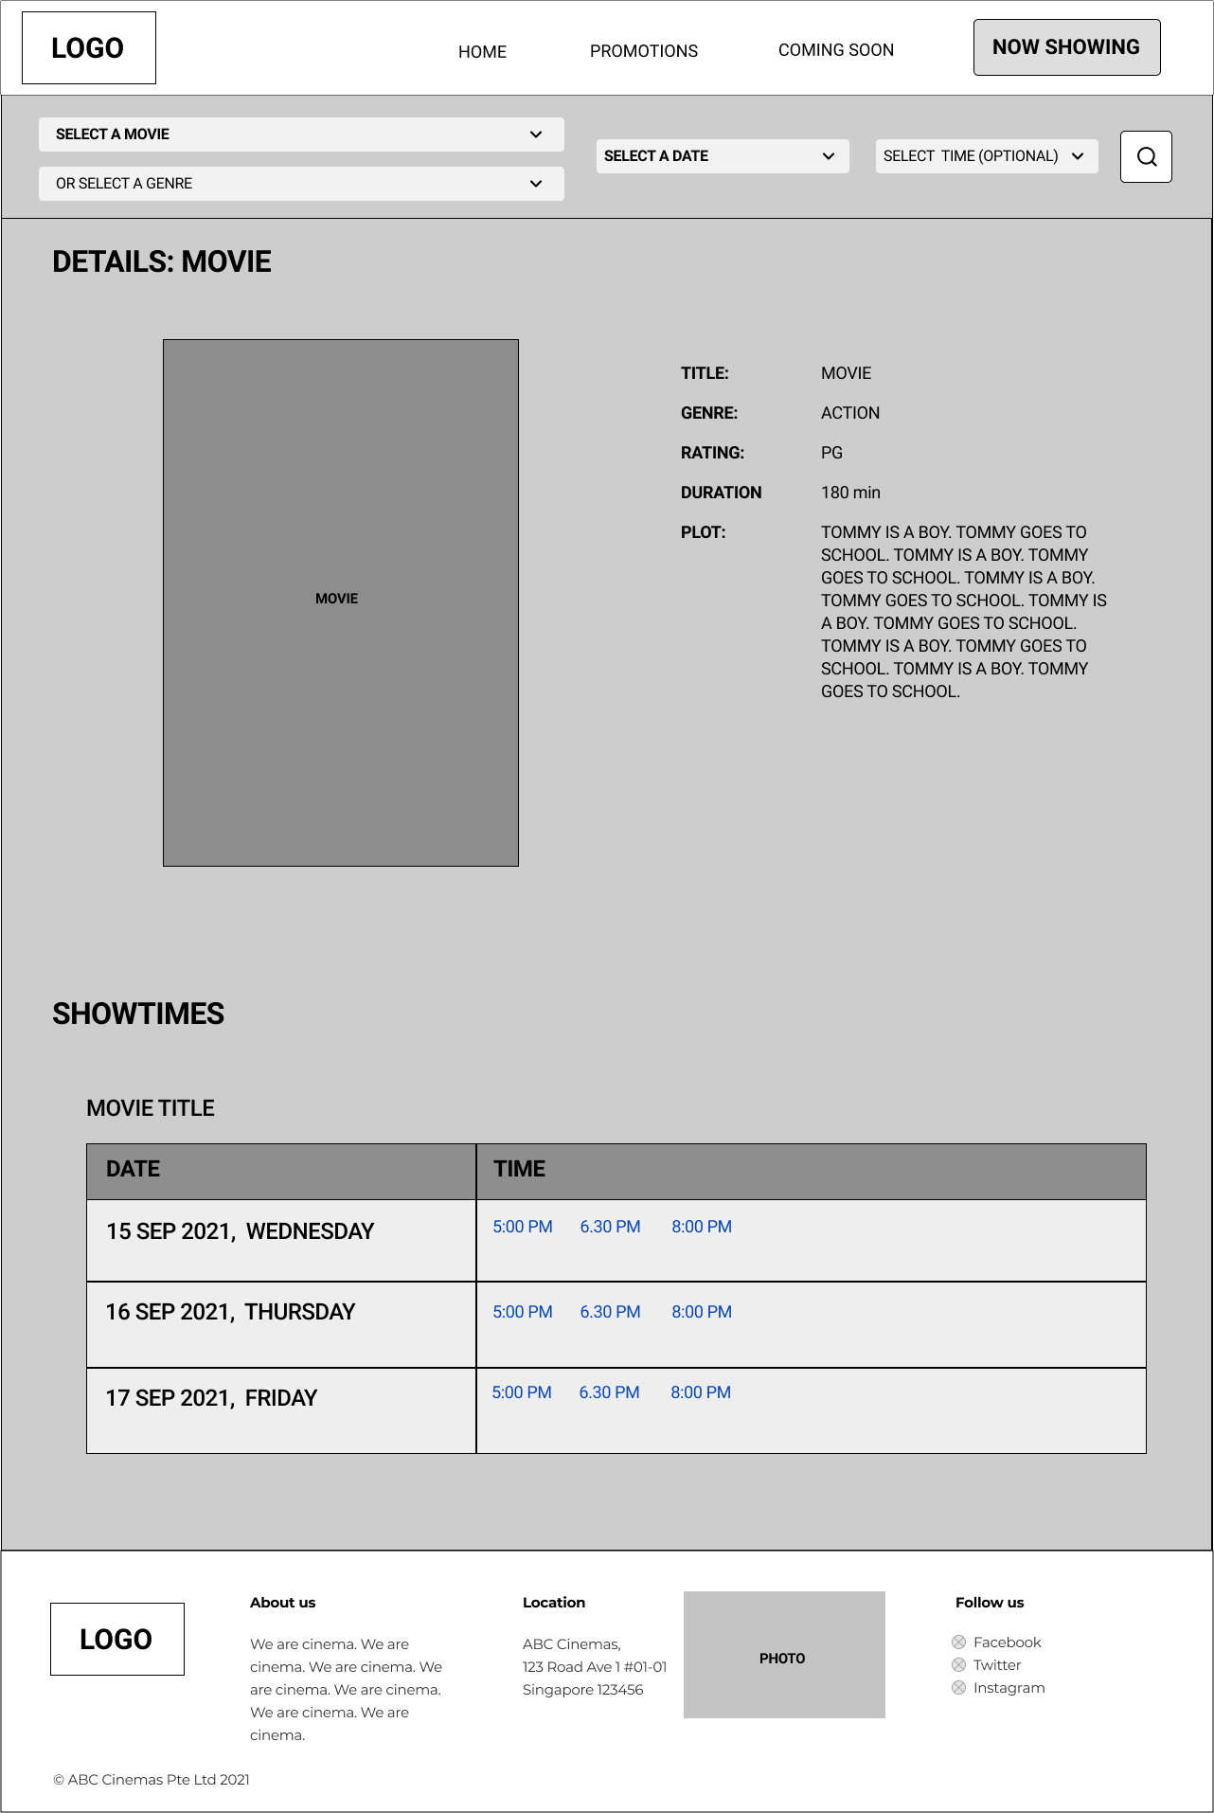

### Movie Showtime (Via search by movie and date)

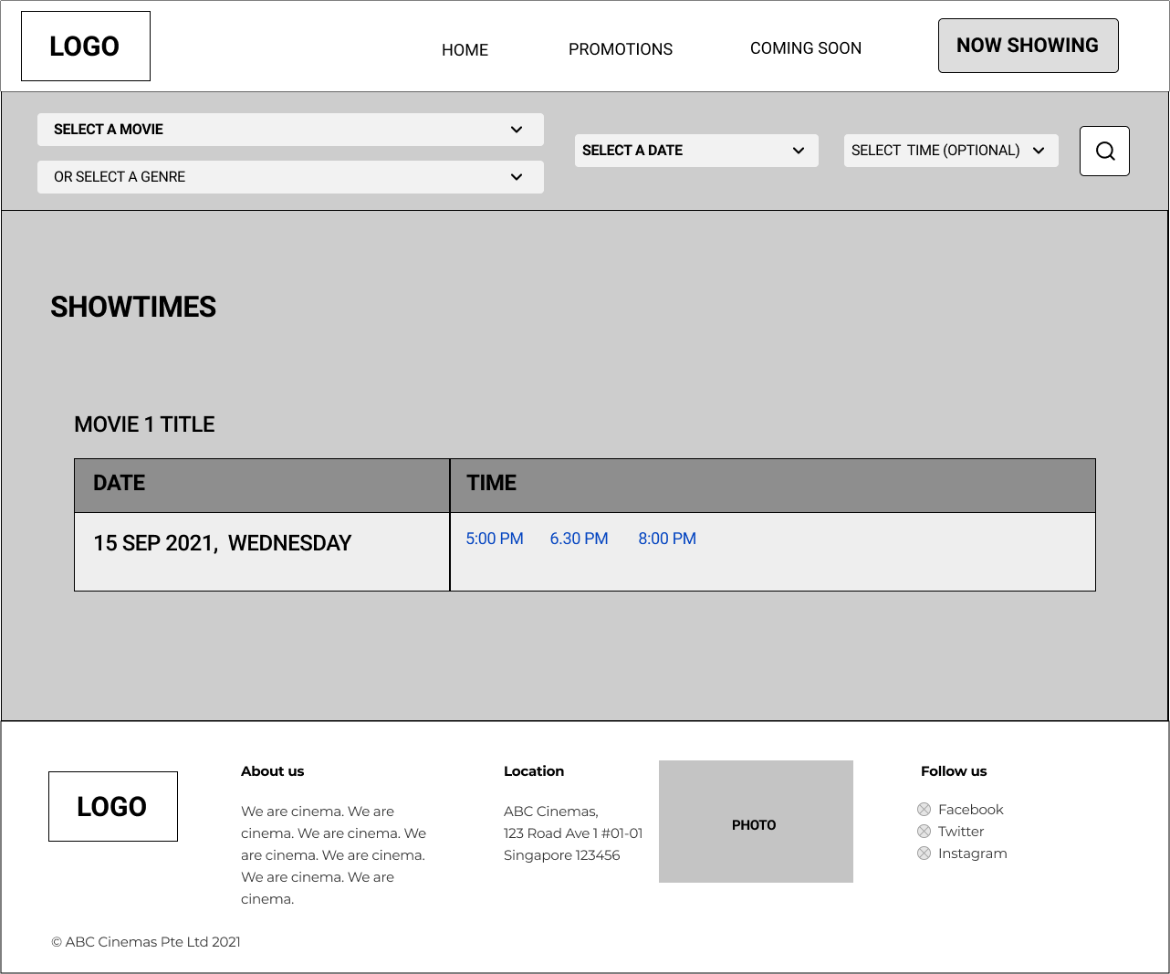

### 

### Genre Showtime (Via search by genre and date)

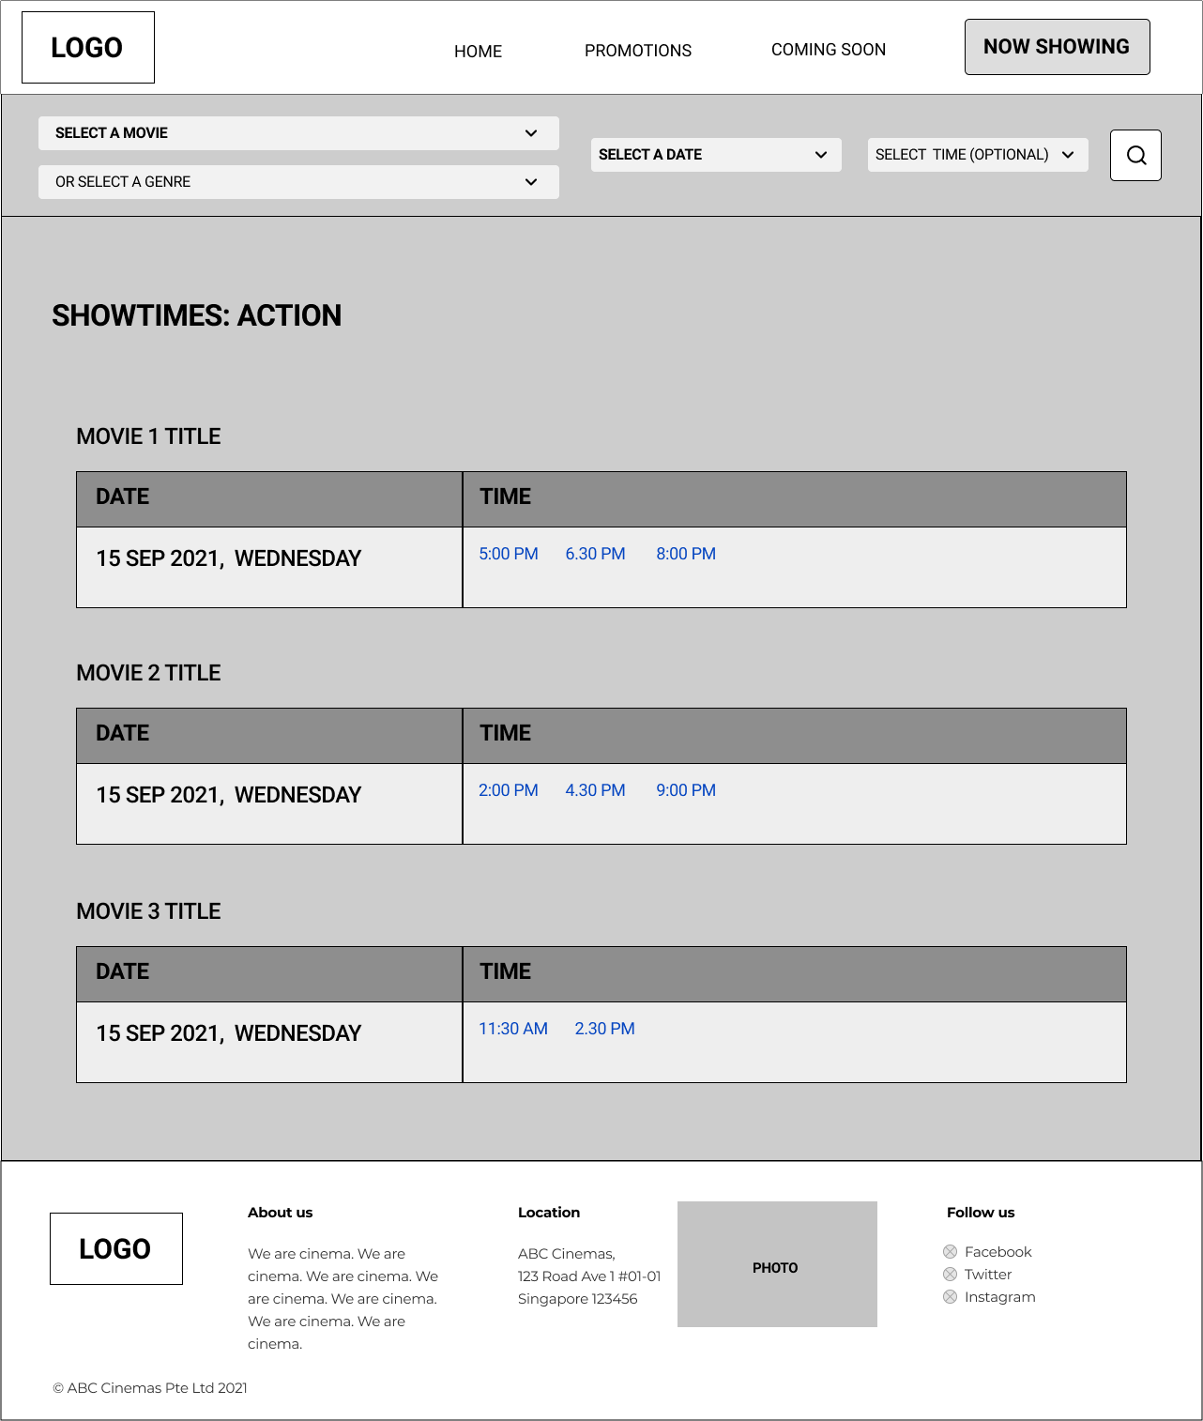

### 

### Seat Selection

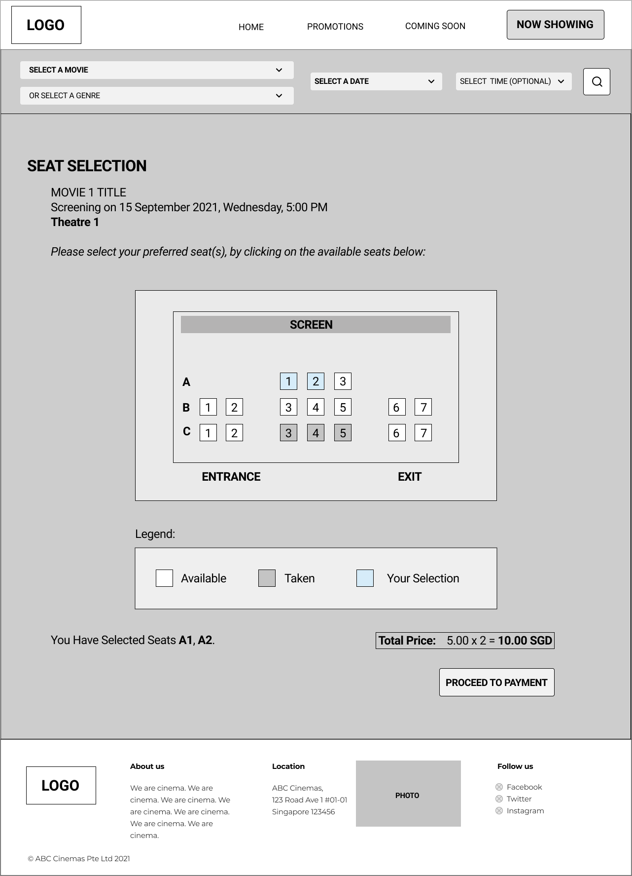

### Transaction Page (Success)

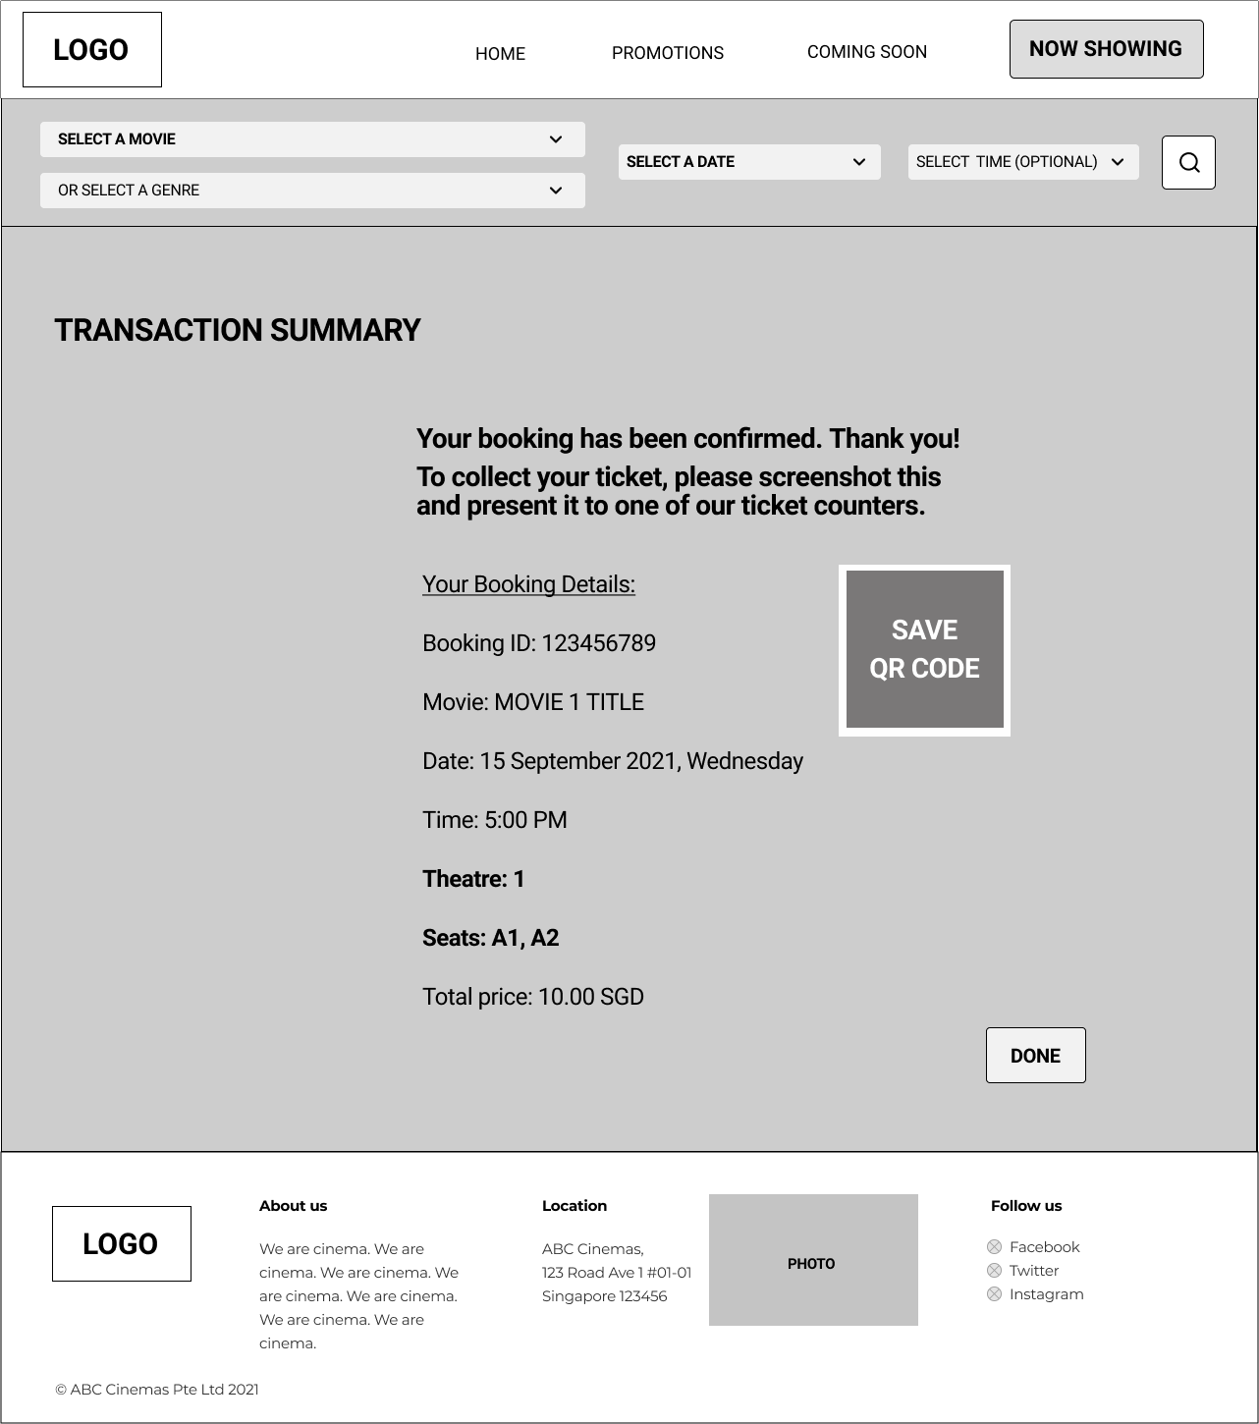

### 

### Transaction Page (Fail)

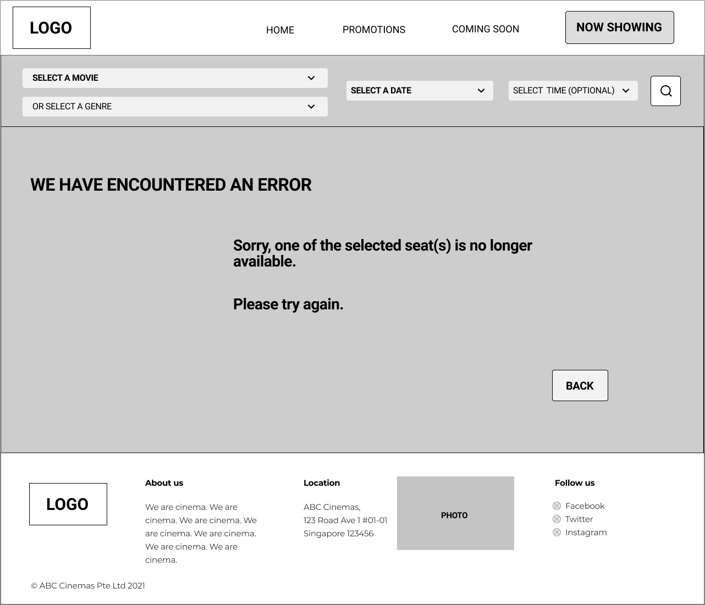

## Implementation details

### CSS

CSS will be used to standardize the color and styling that will be used throughout the entire website.

### Header and Footer

All the webpages will consist of the same header and footer. The header will consist of four links excluding the logo (which also acts as a home button):

1. Home
2. Promotion
3. Coming Soon
4. Now Showing

Each of the links can redirect the user to their respective web pages. The footer contains information about the cinema, such as location.

### Promotion page - Modal

The promotion page will have a grid layout of different promotional posters. Clicking each image will result in a modal being displayed. This modal will be constructed using HTML.

### Search bar

The search bar will be located right below the header on every web page. It will consist of 4 dropdown lists and a search button. Upon entering the website, the movie's data will be retrieved and displayed on these dropdown lists. As mentioned above, users could search based on either genre or movie’s name. After they have done their selection, the data will be stored in different variables using JavaScript and the variables will be sent to the database for data retrieval. The search bar will be created within a Form element to allow for database queries and a GET request.

### Homepage - Carousel

When a user first enters the homepage, it will retrieve the images of the trending movies and promotions to display at the carousel. The image carousel will be created using HTML and it will rotate to highlight several images at a fixed interval. Users may also manually change the highlighted image by clicking on the circle at the bottom or the arrows located at the left and right side of the image

### Movie Gallery

Below the image carousel, movie’s posters will be displayed as a grid, in rows of 3, using a table without borders. Within each image, users can hover over each one to display brief information. This will be done in HTML and CSS.

This gallery layout will also be utilized across other parts of the website such as Now Showing and Coming Soon, allowing for the hover preview and navigation to individual movie pages (Movie Details page).

### Movie Details and Showtime

In their movie’s individual web page, there will be more details on the movies that they have selected. Besides that, at the bottom of the description, there will be a table which consists of the showtimes of the movie. The showtime will be retrieved from the database. Users can select on the showtime which will redirect them to the seat selection page.

### Seat Selection

In the seat selection page, it will display the theater model and the seats are individual buttons. Upon clicking on the seats, the seat number will be displayed at the bottom left while the price of the ticket will be displayed at the bottom right. If the user selects more than one seat, the seats number will be displayed with a comma while the total price will show the total number of seats selected, the ticket price and the total price. After selecting their seats, they can click on ‘Proceed to Payment’ where the 3rd party will handle the process.

This should be a POST request to insert new data. However, validation will be required to check if the requested seat is still available at the time of the request.

### Transaction Page

If no errors were encountered on the backend, the Success page will appear with details of the transaction. These details can simply be retrieved from the database and displayed on the frontend. The user can then click on the ‘Done’ button to return back to the home page.

If errors have been encountered, the Fail version of the page will appear to prompt the user to try again. This error could very likely be due to another user already purchasing the tickets, and therefore updating the database to mark the seat as taken/ unavailable, therefore rejecting a duplicate request to book the same seat. The ‘Back’ button will redirect the user to the previous Seat Selection page, with a refreshed/updated version of the booking status (reflected via the seating model), for them to try another booking.

### 

## Testing of web applications

### Test Case

| **Test ID** | **Condition/Scenario** | **Value / Actions** | **Expected Output** | **Actual Output** | **Status**  **(✔/✖)** |
| --- | --- | --- | --- | --- | --- |
| 1 | Search by movies  (Dropdown lists) | SELECT A MOVIE  OR SELECT A GENRE  SELECT A DATE  SELECT TIME (OPTIONAL)  Click on the search button | Nothing happens |  |  |
| 2 | Search by movies  (Dropdown lists) | Titanic  OR SELECT A GENRE  11 November 2021  SELECT TIME (Optional)  Click on the search button | Redirect to showtime page (Only display Titanic’s showtime) |  |  |
| 3 | Search by movies  (Dropdown lists) | Titanic  OR SELECT A GENRE  11 November 2021  11.50AM  Click on the search button | Redirect to Seat Selections web page |  |  |
| 4 | Search by movies  (Dropdown lists) | Titanic  OR SELECT A GENRE  SELECT A DATE  SELECT TIME (OPTIONAL)  Click on the search button | Redirect to movie details page |  |  |
| 5 | Search by movies  (Dropdown lists) | Select date without selecting movies or genres | Date will be disabled |  |  |
| 6 | Search by genres  (Dropdown lists) | SELECT A MOVIE  Action  SELECT A DATE  SELECT TIME (OPTIONAL)  Click on the search button | Redirect to movie genre page |  |  |
| 7 | Search by genres  (Dropdown lists) | SELECT A MOVIE  Action  11 November 2021  SELECT TIME (OPTIONAL)  Click on the search button | Redirect to showtime page (Display all movies with action genres) |  |  |
| 8 | Search by genres  (Dropdown lists) | Select time after selecting genres | Time will be disabled |  |  |
| 9 | Search by movies & genres  (Dropdown lists) | Select date and time without selecting either movies or genres | Both date and time will be disabled |  |  |
| 10 | Search by movies & genres  (Dropdown lists) | Rush Hour  Action  SELECT A DATE  SELECT TIME (OPTIONAL)  Click on the search button | Redirect to movie details page |  |  |
| 11 | Search by movies & genres  (Dropdown lists) | Rush Hour  Action  11 November 2021  SELECT TIME (OPTIONAL)  Click on the search button | Redirect to showtime page (Only display Rush Hour’s showtime) |  |  |
| 12 | Search by movies & genres  (Dropdown lists) | Rush Hour  Action  11 November 2021  11.50AM  Click on the search button | Redirect to Seat Selections web page |  |  |
| 13 | Menu bar | Click on HOME | Redirect to home page |  |  |
| 14 | Menu bar | Click on PROMOTIONS | Redirect to promotions page |  |  |
| 15 | Menu bar | Click on COMING SOON | Redirect to coming soon page |  |  |
| 16 | Menu Bar | Click on NOW SHOWING | Redirect to now showing page |  |  |
| 17 | Movie Descriptions | Hover on movie’s poster | Show brief movies information |  |  |
| 18 | Search Results  (Via Search Bar) | Click on the movie’s posters | Redirect to the movie’s individual web page |  |  |
| 19 | Selecting of showtime (Movie’s details web page) | Click on the showtime | Redirect to Seat Selections web page |  |  |
| 20 | Selecting of showtime (showtime webpage) | Click on the showtime | Redirect to Seat Selections web page |  |  |
| 21 | Selecting of showtime (Genre’s showtime webpage) | Click on the showtime | Redirect to Seat Selections web page |  |  |
| 22 | Seat selections | Click on Proceed to payment without clicking on any seats | Alert “Please select a seat” |  |  |
| 23 | Seat selections | Click on a unavailable seats | Unable to select |  |  |
| 24 | Seat selections | Click on a seat | Total prices appear at the bottom |  |  |
| 25 | Seat selections | Click on seats and click on Proceed to payment | Redirect to the Transaction page |  |  |
| 26 | Failure Page | Click on Back button | Return to seat selection page |  |  |
| 27 | Confirmation Page | Click on Done button | Redirect to home page |  |  |
| 28 | Promotion page | Click on the promotion image | Display the promotion image in full screen |  |  |